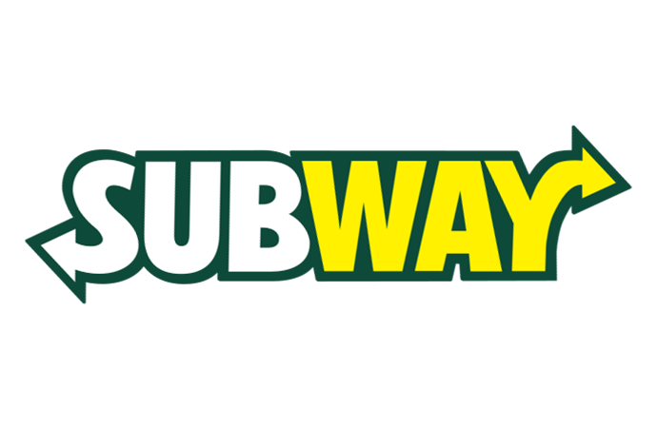



Session: 2021 – 2025

**Submitted by:**

Muhammad Salman 2021-SE-04

Muhammad Farjad 2021-SE-56

**Supervised by:**

Ma’am Zara

Department of Computer Science

**University of Engineering and Technology**

**Lahore Pakistan**.

# Table of context

1. Wireframes ----------------------------------------------------------------------- 03

1.1 Home Page :----------------------------------------------------------- 03

1.2 LOGIN-PAGE : ------------------------------------------------------- 04

1.3 SIGN-UP-PAGE : ---------------------------------------------------- 05

1.4 DESCIPTION : -------------------------------------------------------- 05

1.5 CUSTOMIZE : --------------------------------------------------------- 05

1.6 BUYING PHASE : --------------------------------------------------- 10

1.7 RECIEPT_:----------------------------------------------------------------- 13

# WIREFRAMES : 1.1 Home Page :

## 

|  |  |  |
| --- | --- | --- |
|  | USER | ADMIN |
| T1 | As a user, I shall be able to move to social account of this restaurant | As an admin, I shall able be to give access to the user to move our restaurant social account |
| T2 | As a user, I shall be able to move to the home page | As an admin, I shall be able to change the picture of logo. |
| T3 | As a user, I shall be able to directly move to the spefeic category | As an admin, I shall be able to add , edit and delete categories |
| T4 | As a user, I shall watch and select or for moreinformation about this add | As an admin, I shall be change this advertisement due to new products |
| T5 | As a user, I shall choice the product to the specific type for buying | As an admin, I shall update ( edit, delete ) products |
| T6 | As a user, I shall choice the products which are most popular according to the most visitors | As an admin, I shall be recommended the products whose are most viewed or popular |
| T7 | As a user, I shall be able to see the details of this restaurant | As an admin, I shall be able to edit restaurant details. |

# 

# 1.2 LOGIN-PAGE :

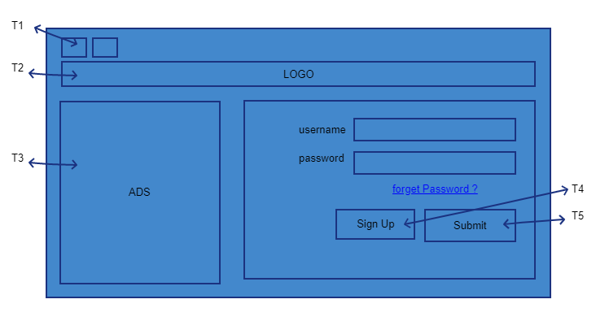

|  |  |  |
| --- | --- | --- |
|  | USER | ADMIN |
| T1 | As a user, I shall be able to jump to social media page of this restaurant. | As an admin, I shall give access to user to jump to respective social media account. |
| T2 | As a user, I shall be able to move to home page of the website. | As an admin, I shall be able to link some other page or change the logo of the website. |
| T3 | As a user, I shall see the products which are most popular according to the most visitors | As an admin, I shall be recommended the products which are most viewed or popular |
| T4 | As a user, I shall be able to create my account. If I don’t have any | As an admin, I shall be give access to the user to create its account . |
| T5 | As a user, I shall after fill the form be able to login my account | As an admin, I shall give access to the user to login through ts account |

# SIGN-UP-PAGE :

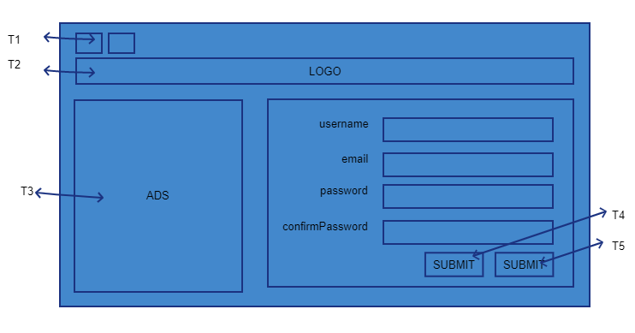

|  |  |  |
| --- | --- | --- |
|  | USER | ADMIN |
| T1 | As a user, I shall be able to jump to social media page of this restaurant. | As an admin, I shall give access to user to jump to respective social media account. |
| T2 | As a user, I shall be able to move to home page of website. | As an admin, I shall be able to change picture of logo. |
| T3 | As a user, I shall see the products which are most popular according to the most visitors | As an admin, I shall be recommended the products which are most viewed or popular |
| T4 | As a user, I shall be able to create my account. | As an admin, I shall be able to verify user’s password and email. |
| T5 | As a user, I shall | As an admin, I shall |

# DESCIPTION :

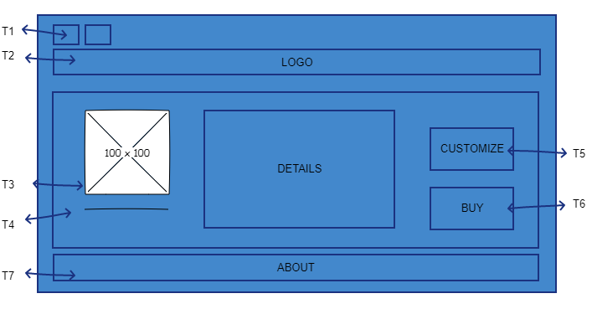

|  |  |  |
| --- | --- | --- |
|  | USER | ADMIN |
| T1 | As a user, I shall be able to jump to social media page of this restaurant. | As an admin, I shall give access to user to jump to respective social media account. |
| T2 | As a user, I shall be able to move to home page of website. | As an admin, I shall be able to change picture of logo. |
| T3 | As a user, I shall be able to see selected eatable. | As an admin, I shall be able to change that particular picture. |
| T4 | As a user, I shall see the description of the selected item. | As an admin, I shall be able to change item’s description |
| T5 | As a user, I shall move to customizing page for the selected item. | As an admin, I shall change the customization page link. |
| T6 | As a user, I shall move to account verification page for buying the selected item. | As an admin, I shall be able to verify the customization and link the user to buying phase. |
| T7 | As a user, I shall be able to see about info of the restaurant. | As an admin, I shall be able to change the about info of the restaurant. |

# CUSTOMIZE :

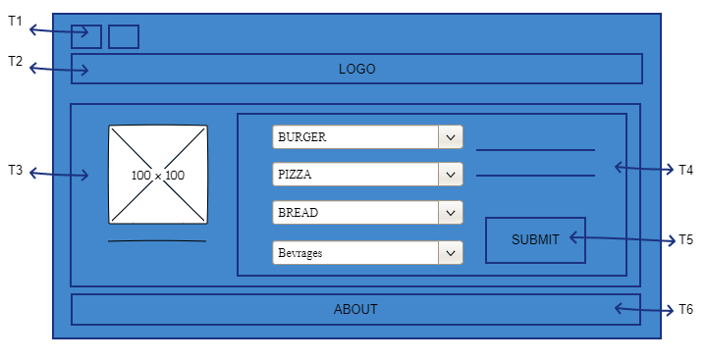

|  |  |  |
| --- | --- | --- |
|  | USER | ADMIN |
| T1 | As a user, I shall be able to jump to social media page of this restaurant. | As an admin, I shall give access to user to jump to respective social media account. |
| T2 | As a user, I shall be able to move to home page of website. | As an admin, I shall be able to change picture of logo. |
| T3 | As a user, I shall see picture of the item and its description. | As an admin, I shall change the picture and description of the item |
| T4 | As a user, I shall be able to write the respective toppings and stuff like that. | As an admin, I shall get the user’s taste of meal. |
| T5 | As a user, I shall submit my customization description. | As an admin, I shall verify user’s customized description. |
| T6 | As a user, I shall be able to get the info about the restaurant. | As an admin, I shall be able to display about info of the restaurant. |

# BUYING PHASE :

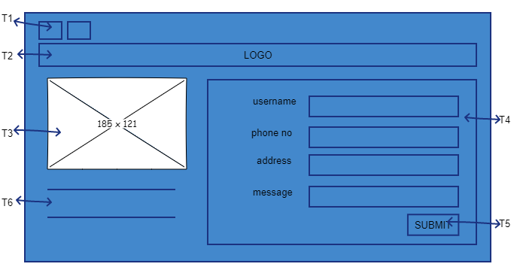

|  |  |  |
| --- | --- | --- |
|  | USER | ADMIN |
| T1 | As a user, I shall be able to jump to social media page of this restaurant. | As an admin, I shall give access to user to jump to respective social media account. |
| T2 | As a user, I shall be able to move to home page of website. | As an admin, I shall be able to change picture of logo. |
| T3 | As a user, I shall be able to see final slected item after the customization. | As an admin, I shall display the user its final product. |
| T4 | As a user, I shall enter my account info. | As an admin, I shall look user’s account info. |
| T5 | As a user, I shall be able to submit my account and product info. | As an admin, I shall be able to verify user’s account and product info. |
| T6 | As a user, I shall | As an admin, I shall |

# RECEIPT :

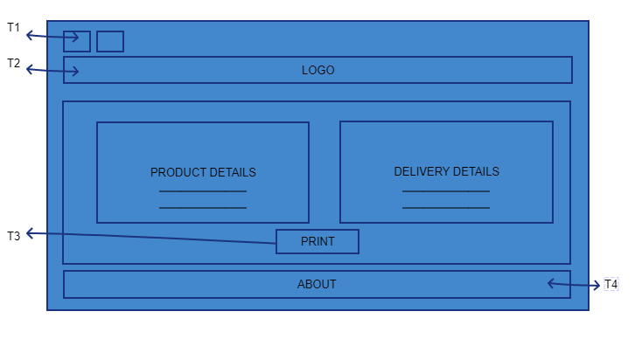

|  |  |  |
| --- | --- | --- |
|  | USER | ADMIN |
| T1 | As a user, I shall be able to jump to social media page of this restaurant. | As an admin, I shall give access to user to jump to respective social media account. |
| T2 | As a user, I shall be able to move to home page of website. | As an admin, I shall be able to change picture of logo |
| T3 | As a user, I shall be able to print receipt. | As an admin, I shall display user receipt . |
| T4 | As a user, I shall be able to see about info of the restaurant. | As an admin, I shall be able change about info of the restaurant. |